

Design Document:

Pretups Mobile Application.

Commission calculator.

Version: 1.0

Date: 05-08-2015

Contents

Introduction 3

1.1. Overview 3

1.2. Objective and Scope 3

1.3. Commission Calculator

**UxDESIGN**..............................................................................................................................................................4

Introduction

## Overview

Commission Calculator service will help the retailer/channel user to analyse the benefits of buying stock from Operator. It helps retailer to know the net commission that will be earned by channel user for buying the stocks from operator and selling the stock to subscriber. It helps retailer to estimate the earning from buying and selling the stock so that retailer can plan accordingly

## Objective and Scope

The objective of this document is to provide a feature design of the service called Commission Calculator

## Commision Calculator

1) User clicks on the link commission calculator then screen navigated to commission calculator screen.

2) User enters the amount in the amount field.

3) User selects the service type to be commission calculated.

4) User selects the commission type normal or additional to be calculated for the service.

5) User clicks on the calculate button, Based on the Operator commission flag the Request is Handled

**5-Case1:** If Flag is True then the request is send to pretups server to get the commission amount calculated

**5-Case2:** If Flag is False then webaxn server will process the request and responds to user based on the Commission configuration setup is configured in webaxn server to get the commission amount calculated.

**Note:** Currently there is no API from pretups side for this Service.

uxDesign

Screen1:

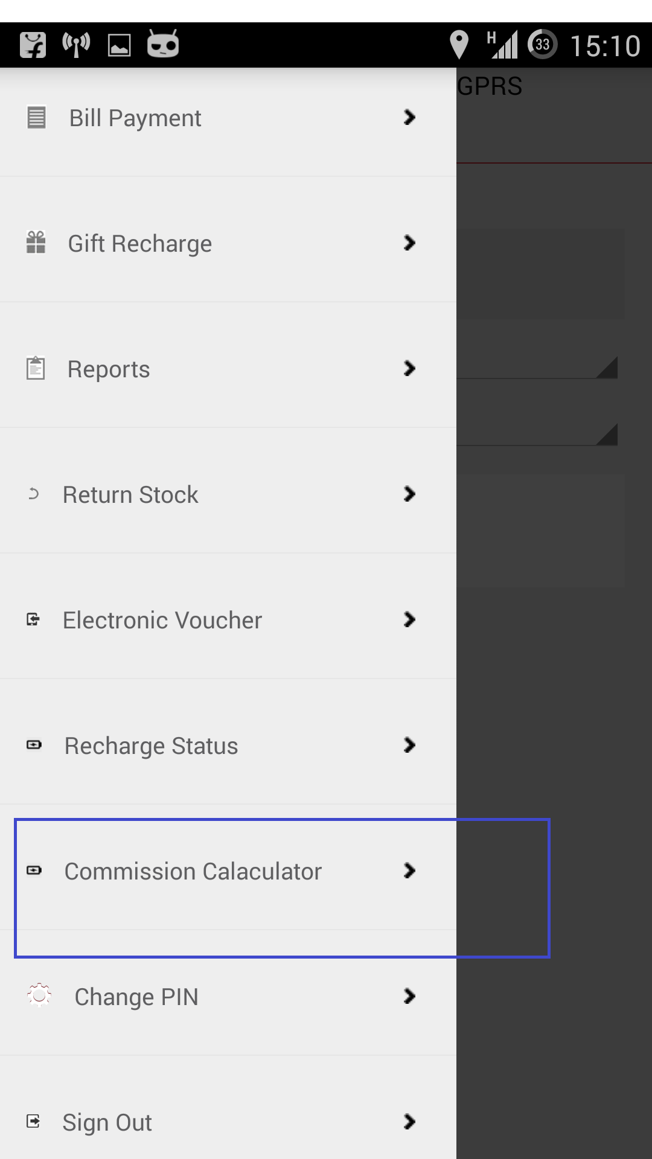Screen 2: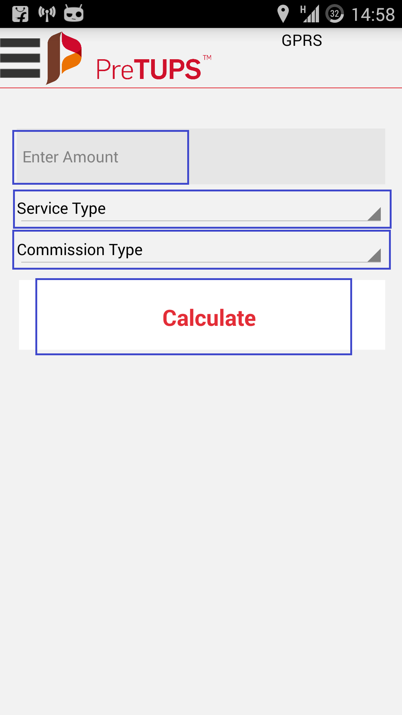

**Case1: If service Type is selected as C2S then showing another select box populating the services like recharge, bill payment etc and commission type for C2S services is Additional only.**

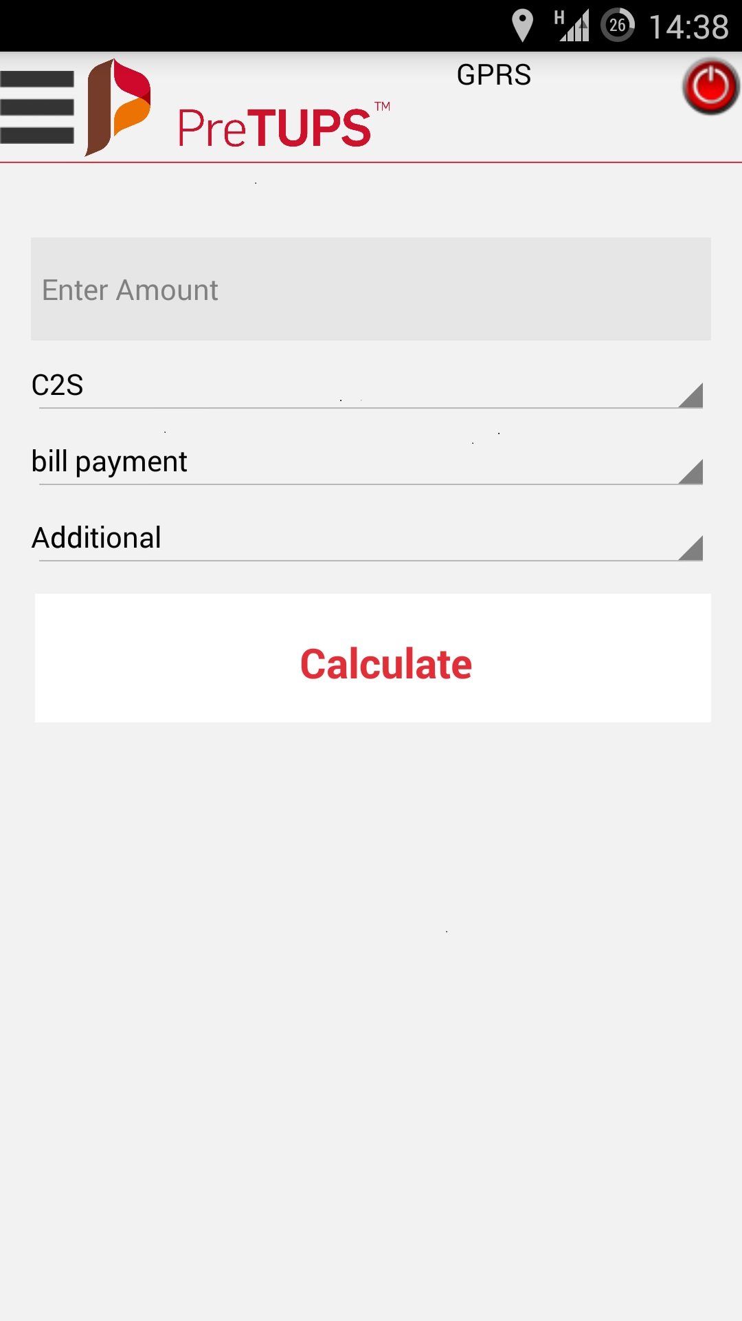

**Case2: if service type is selected as O2C, then commission type for O2C services is Normal only.**

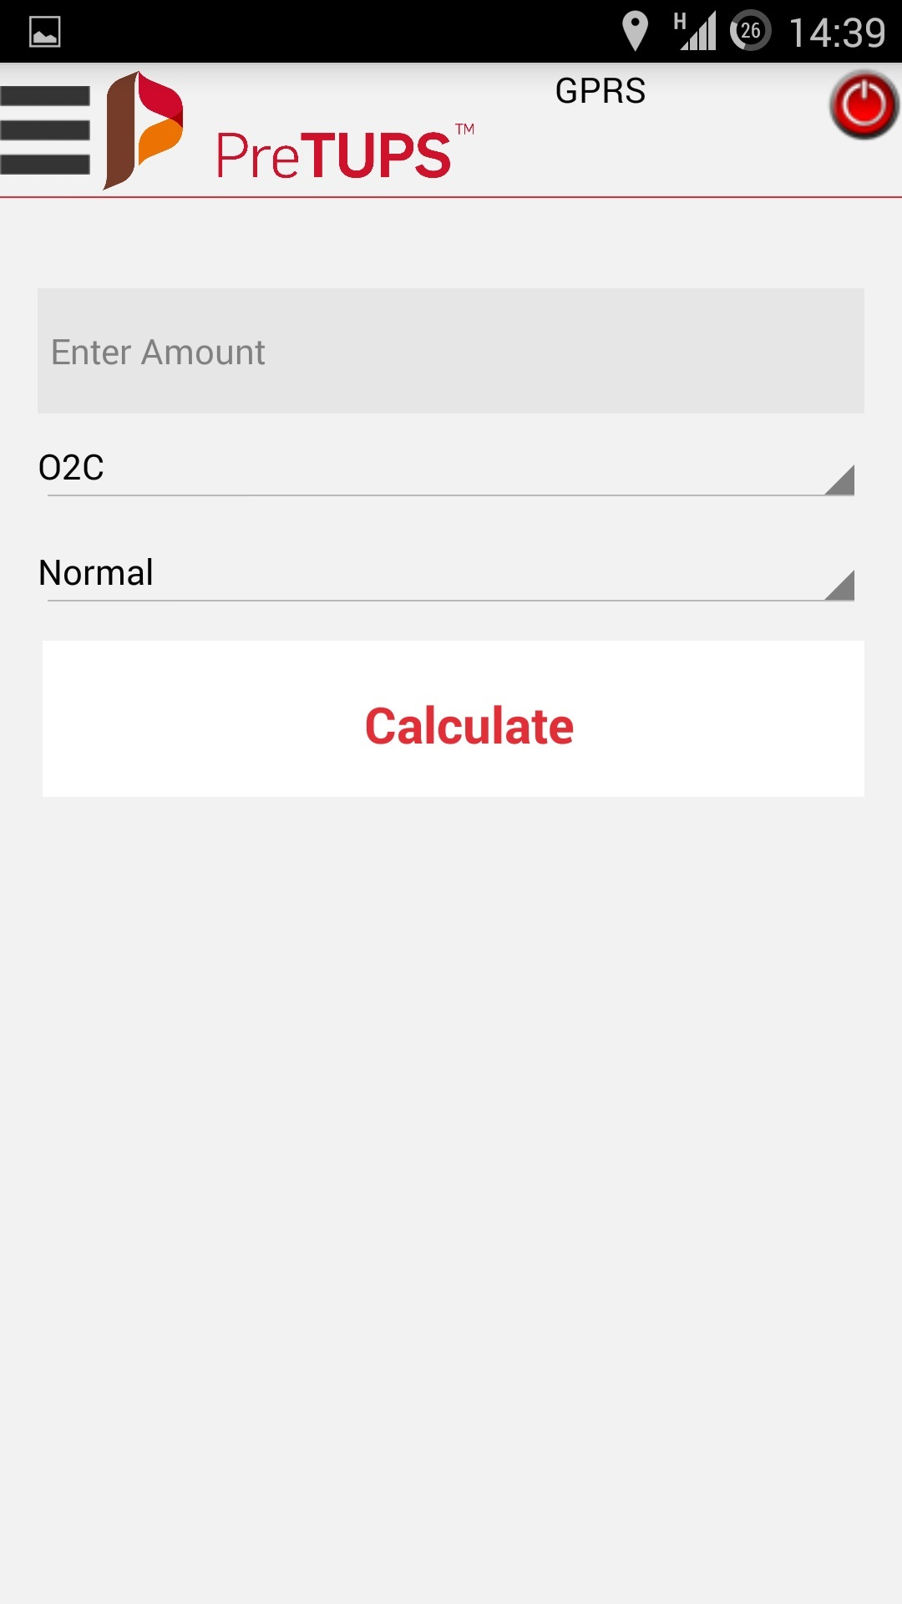

**Case3: If service type selected as C2C, then commission type for C2C services is Normal only.**

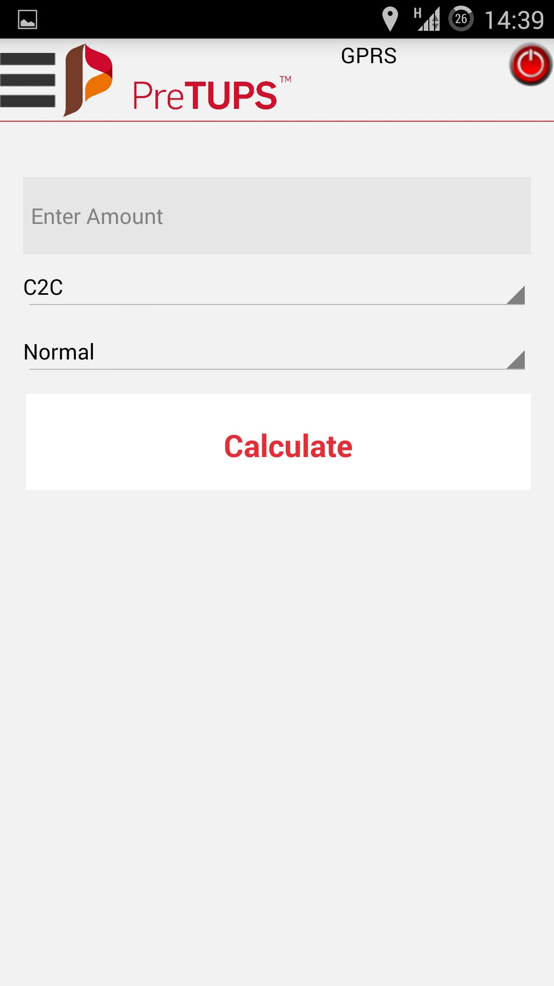

Contact Us

**Corporate Office**

A-26, Info City

Sector 34

Gurgaon 122001

Haryana, India

T: +91-124-4819000

F: +91-124-4819777

**Bangalore Office**

Kirloskar Business park

#50,51, Hebbala, Kempapura,

Next to Columbia Asia Hospital,

Bellary Road,

Bangalore - 560024

India

T: +91-80-43401600

F: +91-80-28565854

**Mumbai Office**

Unit 1-4, 1st Floor, Paradigm Tower

Tower B, Mindspace

Malad(W),

Mumbai 400064,

India

T: +91-22-40774300

F: +91-22-40774333

Restrictions and Copyright Declaration

The information in this document is subject to change without notice and describes only the product defined in the introduction of this documentation. This document is intended for the use of prospective Comviva customers for the sole purpose of the agreement under which the document is submitted. No part of it may be reproduced or transmitted in any form or means without the prior written permission of Comviva. The intended audience for this document is professional personnel, who assume full responsibility for using the document appropriately. Comviva welcomes customer comments as part of the process of continuous development and improvement of its documentation. The information or statements given in this document concerning the suitability, capacity, or performance of the mentioned hardware or software products cannot be considered binding, but shall be defined in contextual specific eventual agreement made between Comviva and the customer.

However, Comviva has made all reasonable efforts to ensure that the instructions contained in the document are adequate, sufficient and free of material errors and omissions. Comviva will, if necessary, explain issues, which may not be covered by the document. Comviva’s liability for any errors in the document is limited to the documentary correction of errors. Comviva will not be responsible, in any event, for errors in this document or for any damages, incidental or consequential, including monetary losses that might arise from the use of this document or the information in it.

This document and the product it describes are considered protected by Patent, Copyright and Trademark laws in accordance with relevant Indian laws.

The only warranties for Comviva products and services are set forth in the express warranty statements accompanying its products and services. Nothing herein should be construed as constituting an additional warranty. Comviva shall not be liable for technical or editorial errors or omissions contained herein.

The Comviva logo is a registered trademark of Comviva Technologies Limited. Other product names mentioned in this document may be trademarks of their respective companies and they are mentioned for identification purposes only.

Copyright © 2014 Comviva Technologies Limited. All rights reserved.